HW4 Meltdown

0616098 黃秉茂

Make sure my CPU is vulnerable to Meltdown.

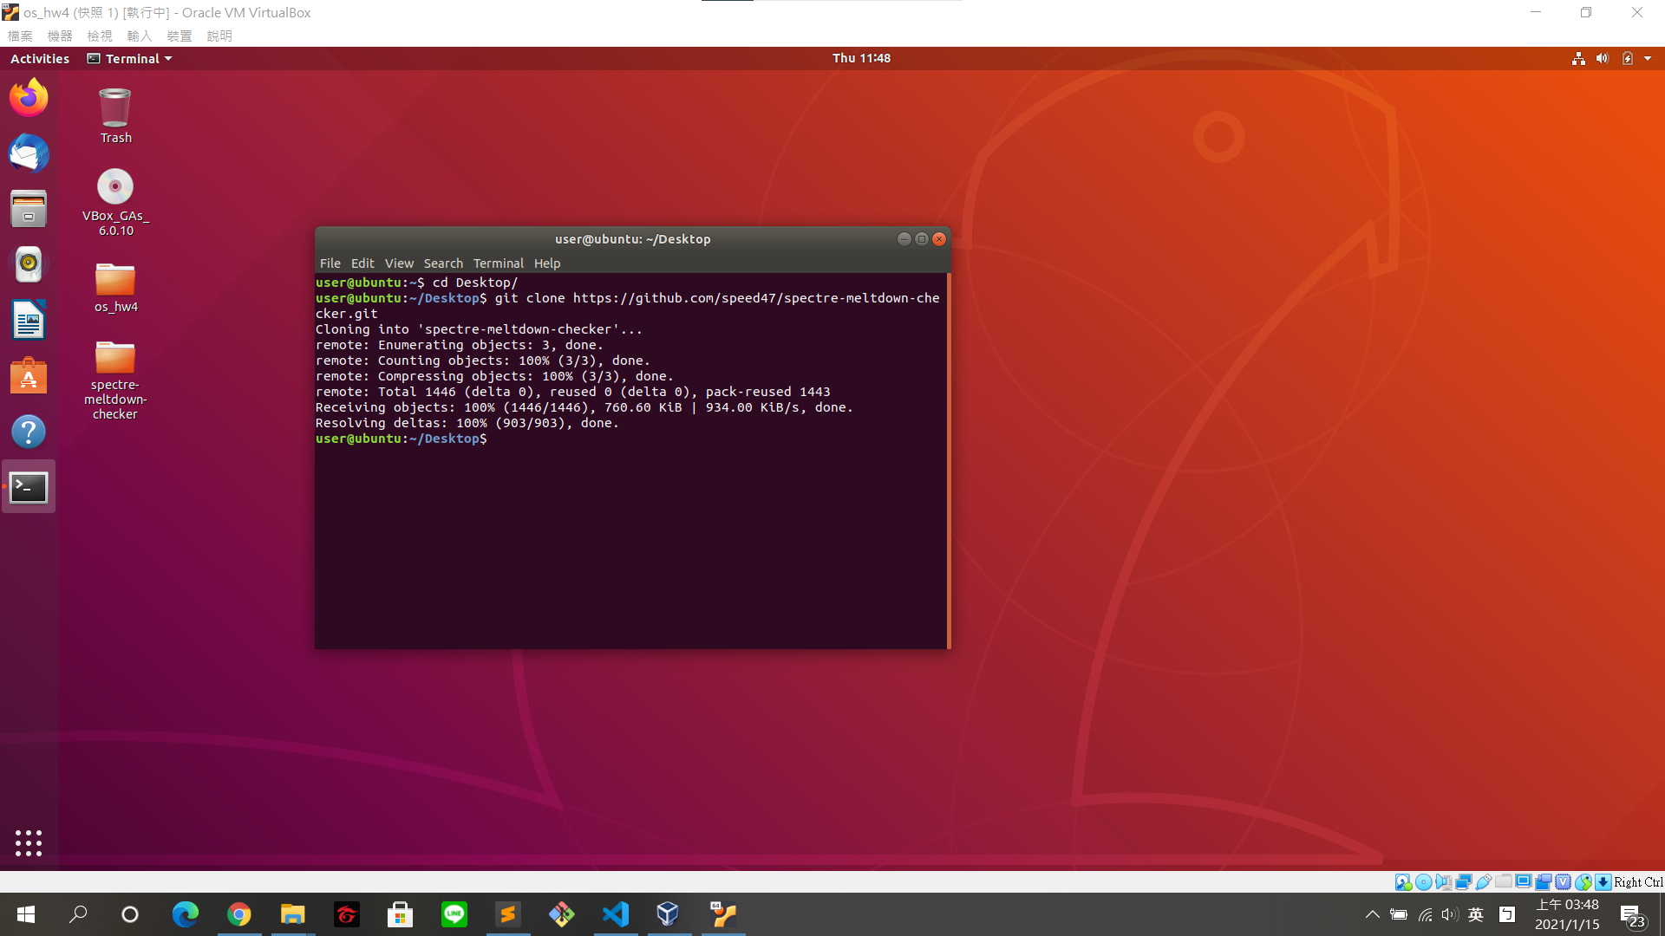

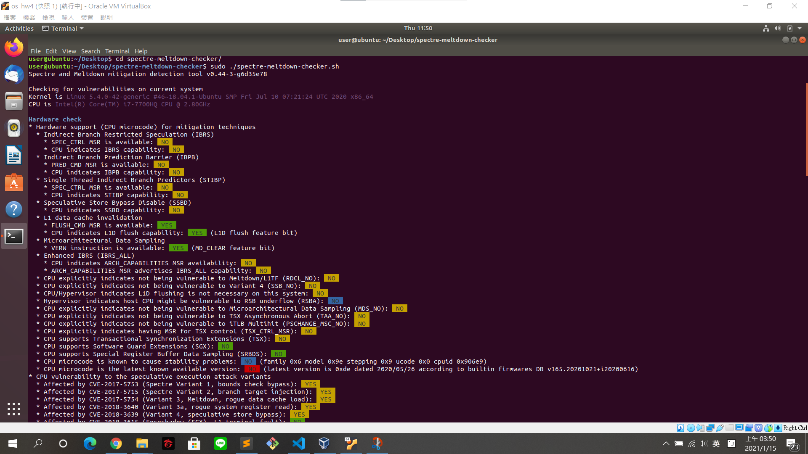

Find my CPU is vulnerable to Meltdown.

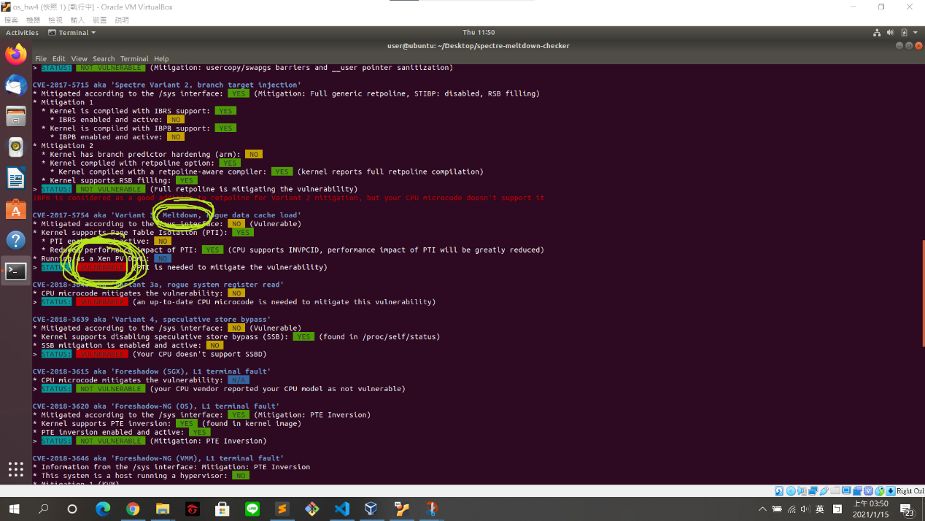

Secret data

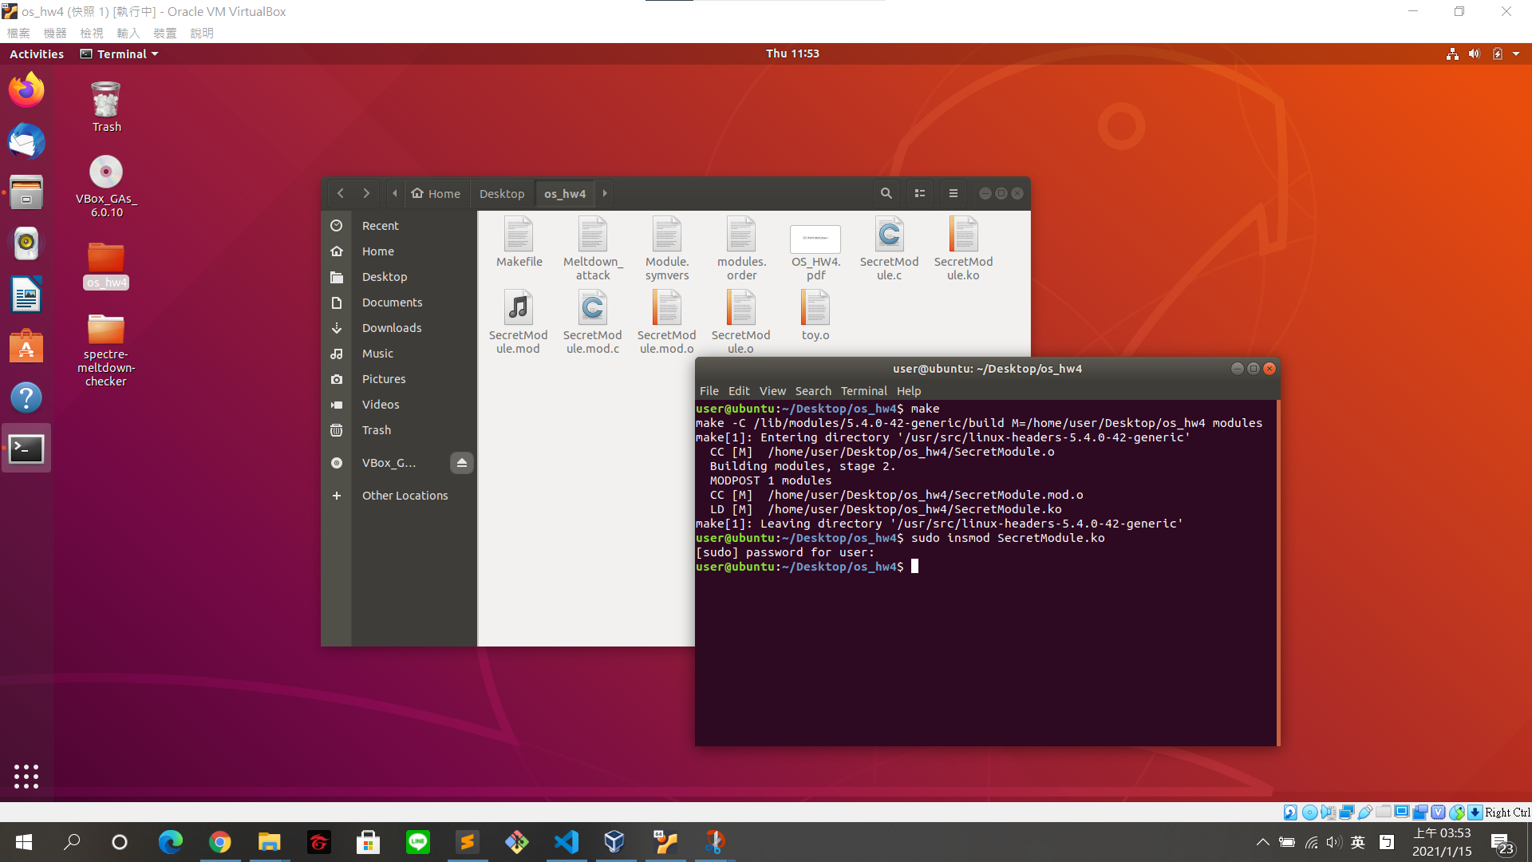

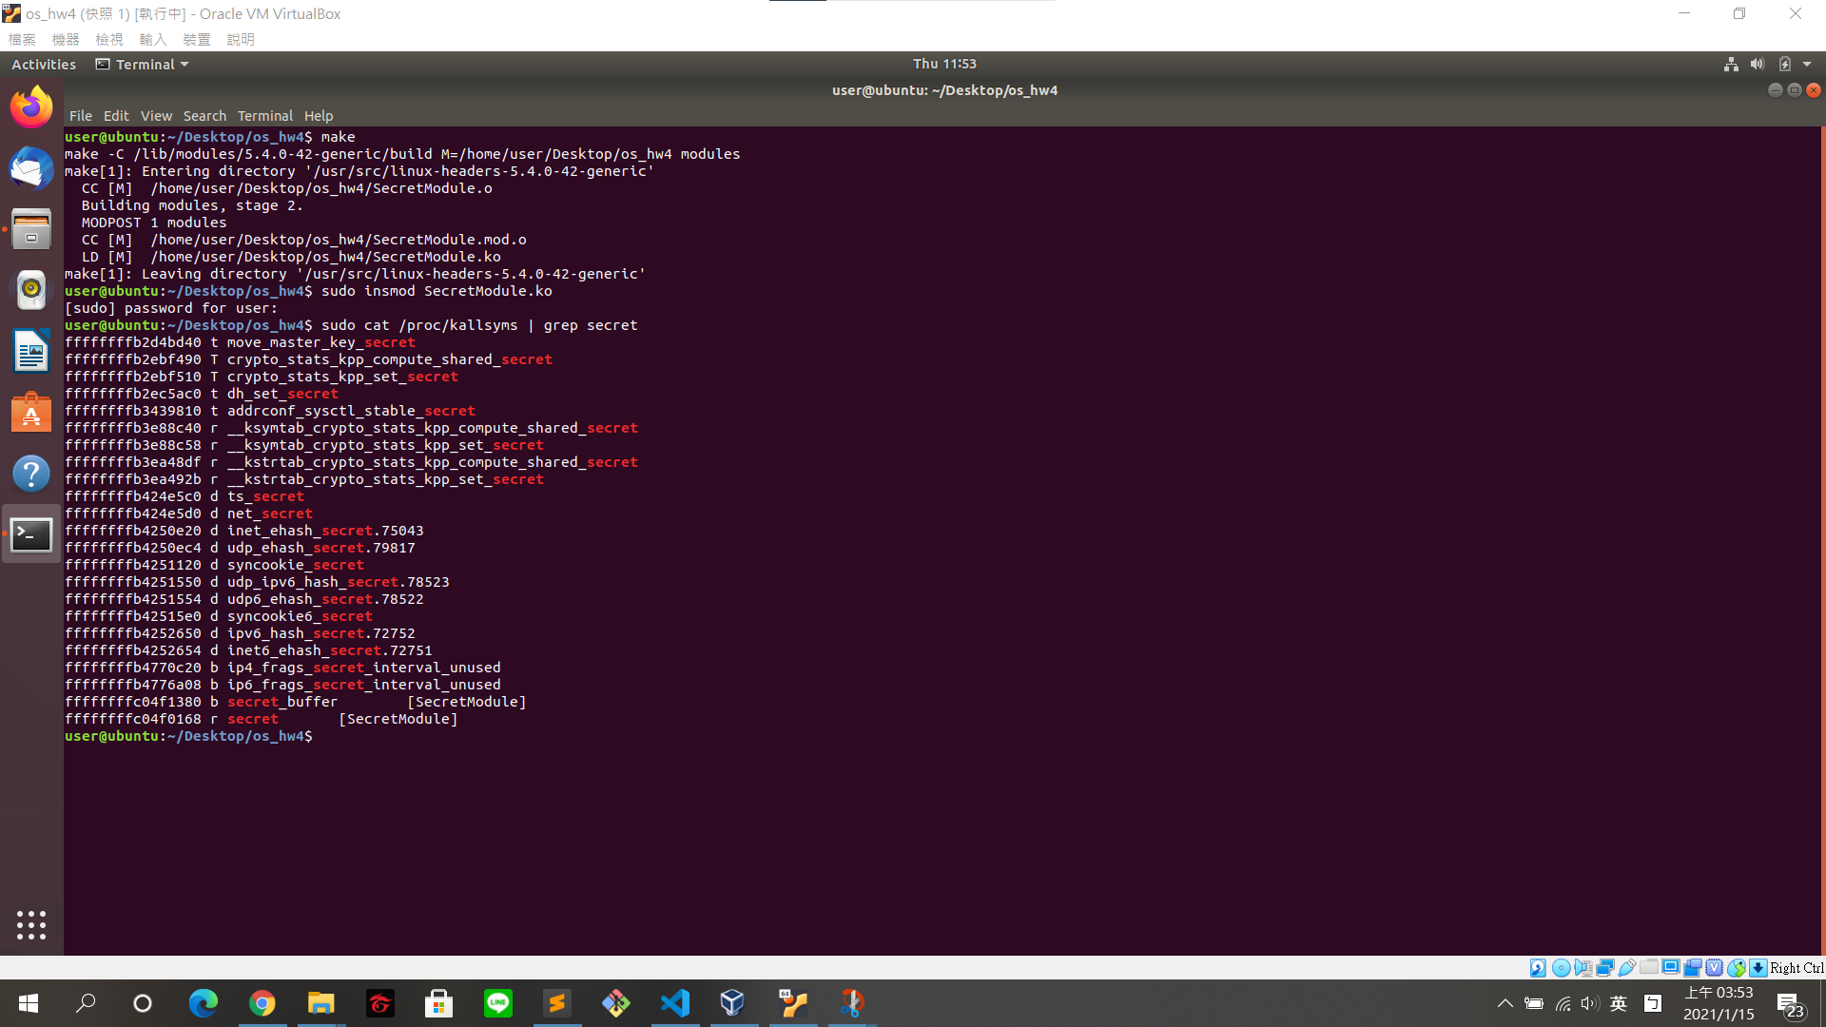

Simply describe how Meltdown exploits OOO execution/Speculative

Execution/Flush+Reload to launch attacks

用Flush+Reload來檢測是否指定的記憶體地址被cache了

Flush+Reload 方法遍歷probe_array陣列中的各個page並計算該page資料的訪問時間而繪製的坐標圖。page index有256個，如果cache miss，那麼訪問時間大概是400~500多個cycle，如果cache hit，訪問時間大概是200個cycle以下，二者有顯著的區別。雖然由於異常，probe_array陣列訪問不應該發生，不過卻能發現明顯是cache hit的，這也說明瞭在亂序執行下，本不該執行的指令也會影響CPU微架構狀態。

A secret byte you want to read is stored at inaccessible memory location.

The sender triggers an access exception by attempting to read memory location.

Due to CPU optimization (out-of-order execution), the load of secret from the memory location may execute before the exception is triggered.

Calculate an offset into a known array probe by multiplying secret by the width of a cache line (or whatever block size the CPU typically fetches, like a 4096-byte page). This guarantees each of those 256 possible offsets will cache separately.

Load probe[offset], which causes the CPU to cache exactly one chunk of of our array, populating one cache line.

The exception finally triggers, clearing the modified registers...but cached data is not excised.

Iterate over all 256 offsets into probe to find out which one loads fast. You've determined the value of secret.

Task1 - run toy.o

$ sudo ./toy.o [kernel_addr]

$ ./toy.o ffffffffc04f0168 (secret_addr)

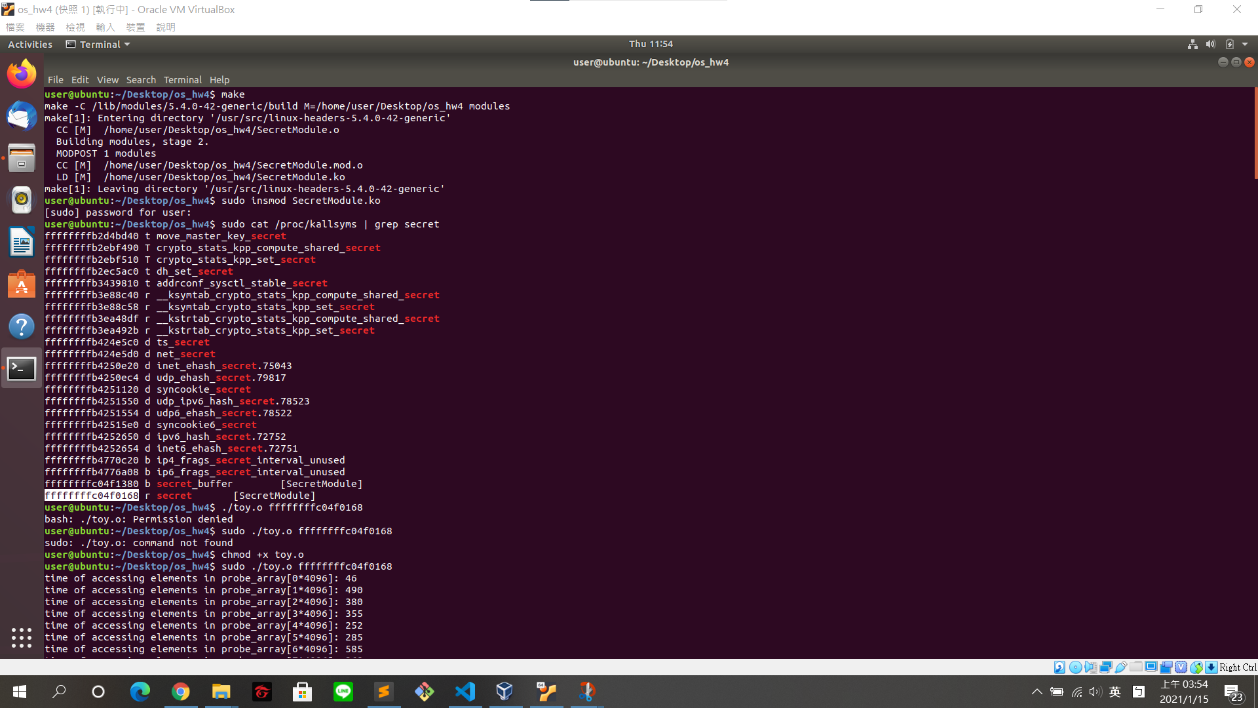

What do you observe?

Explain the result with the provided code above.

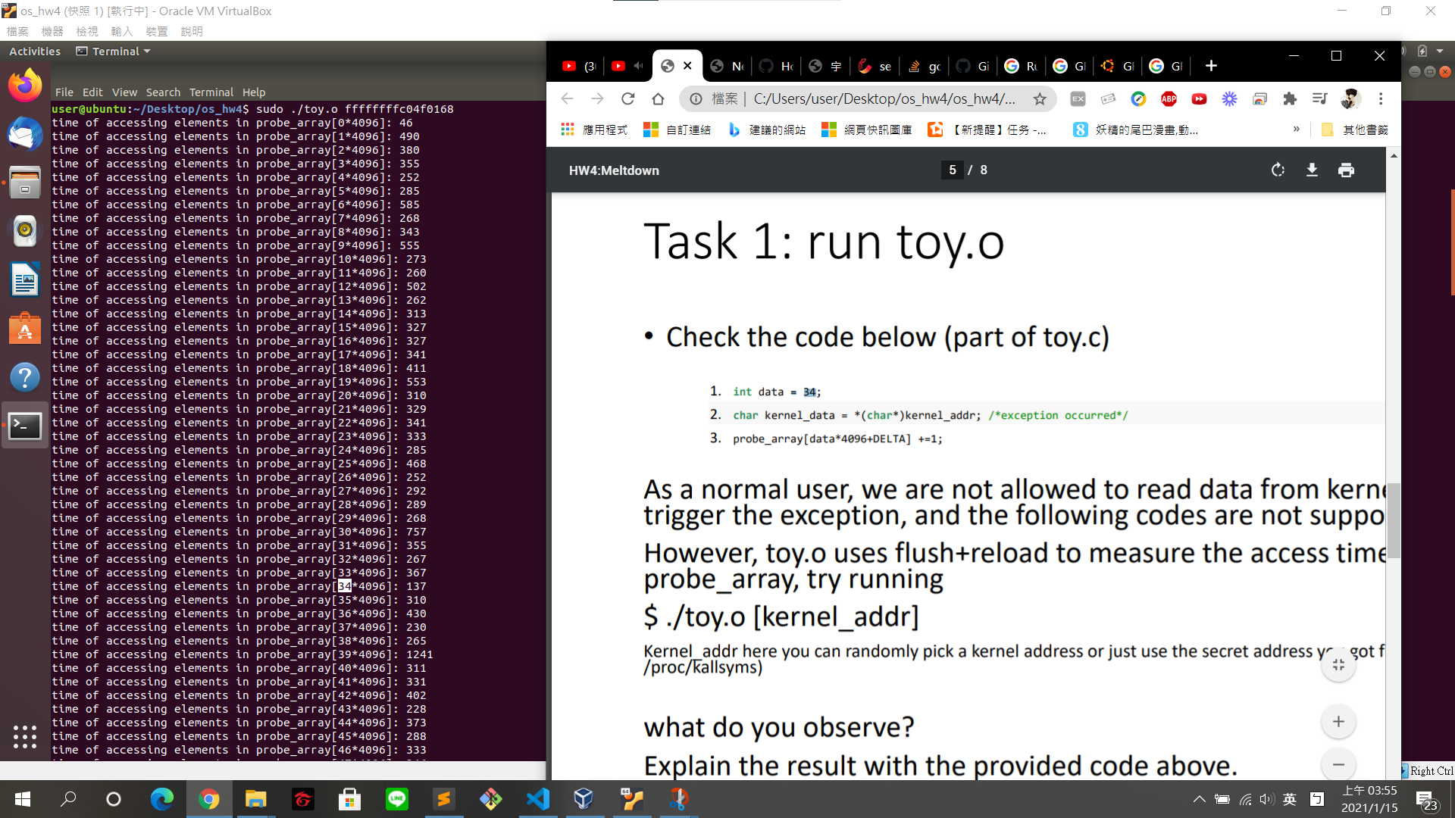

發現probe_array[34*4096]的access time 特別低，而34也剛好是data，其實是因為錯續導致先執行一些下面的code，導致data指定的index會被cache到。我們用Flush+Reload，來檢測是否指定的記憶體地址被cache了，data數值和probe_array陣列中的頁面是一一對應的。

One cache hit, exactly on the page 34 that was accessed during the out of-order execution. Although the array access should not have happened due to the exception, we can clearly see that the index 34 which would have been accessed is cached because of its low access time. Iterating over all pages shows only a cache hit for page 34. This shows that even instructions which are never actually executed, change the microarchitectural state of the CPU.

Task2 - run Meltdown_attack

$ ./Meltdown_attack [secret_addr] [number of bytes to read] [cache_hit_threshold]

$ ./Meltdown_attack ffffffffc04f0168 25 137

(137為probe_array[34*4096]的access time)

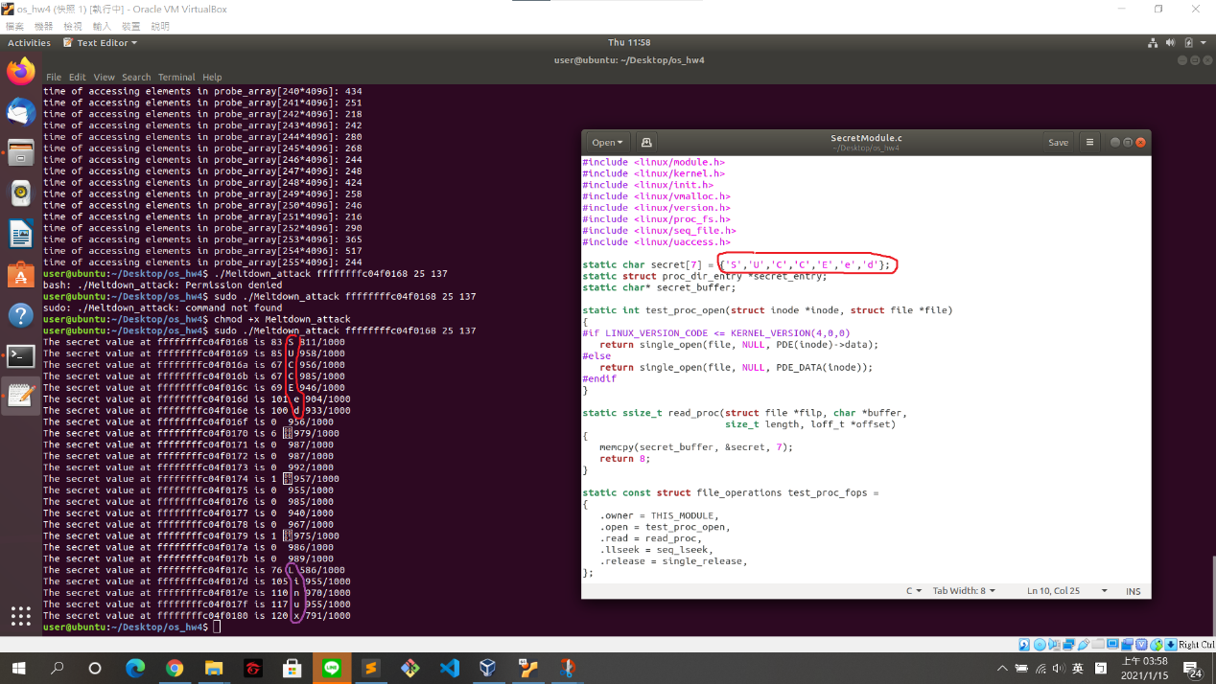

dump the secret that stores in kernel memory with user privilege

發現會出現SUCCEed和linux，而SUCCEed是我們的secret

Task3 – Software Patch of Meltdown

Edit /etc/default/grub

Delete nopti from GRUB_CMDLINE_LINUX_DEFAULT

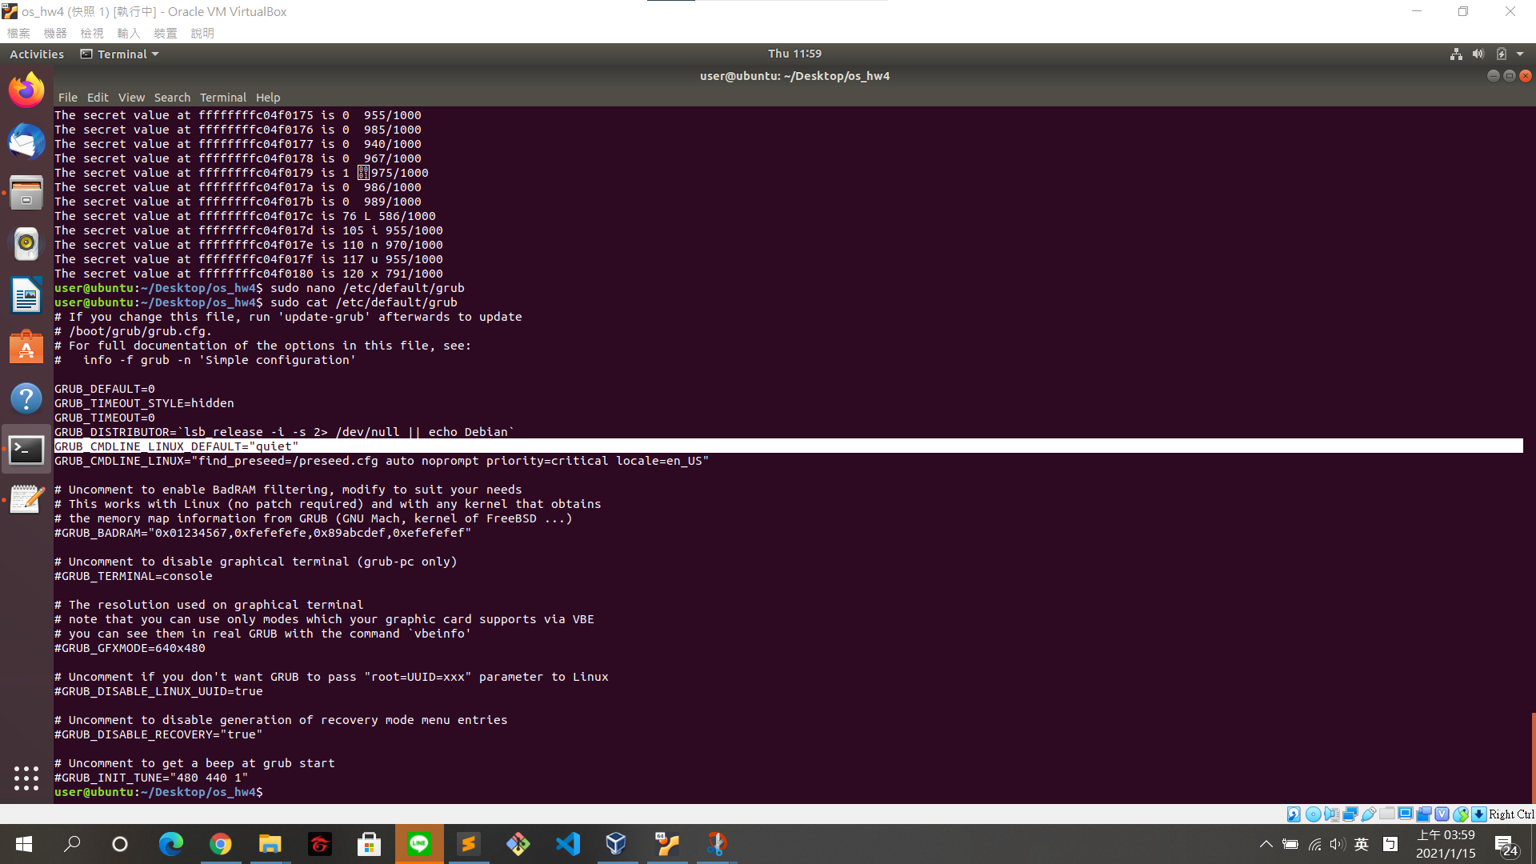

Run update-grub and reboot

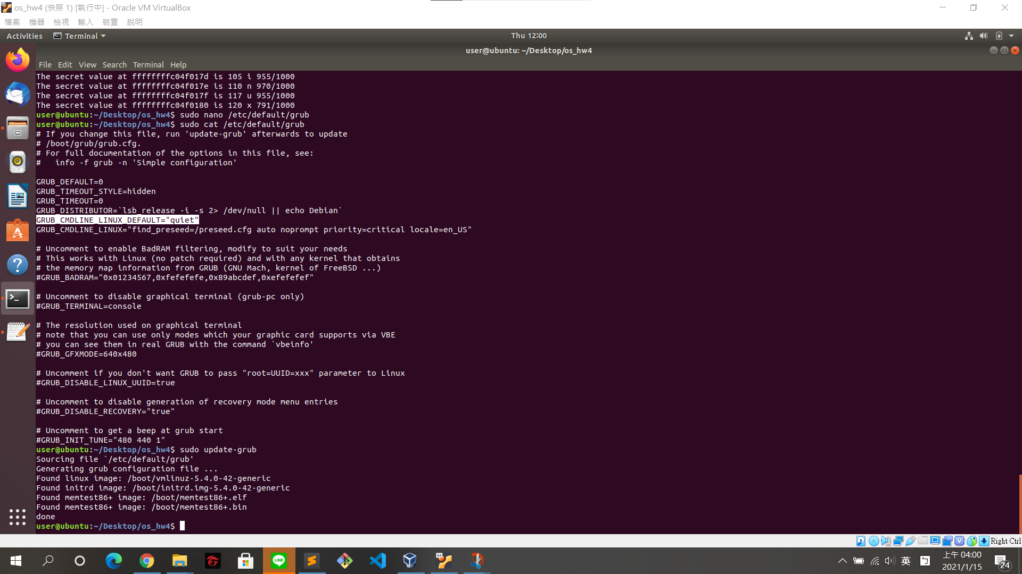

compare the results before and after patch and explain ptimitigation for Ubuntu

vulnerable to Meltdown

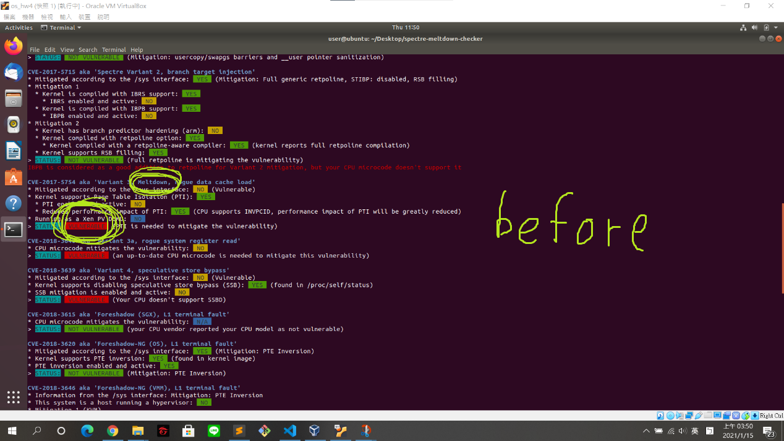

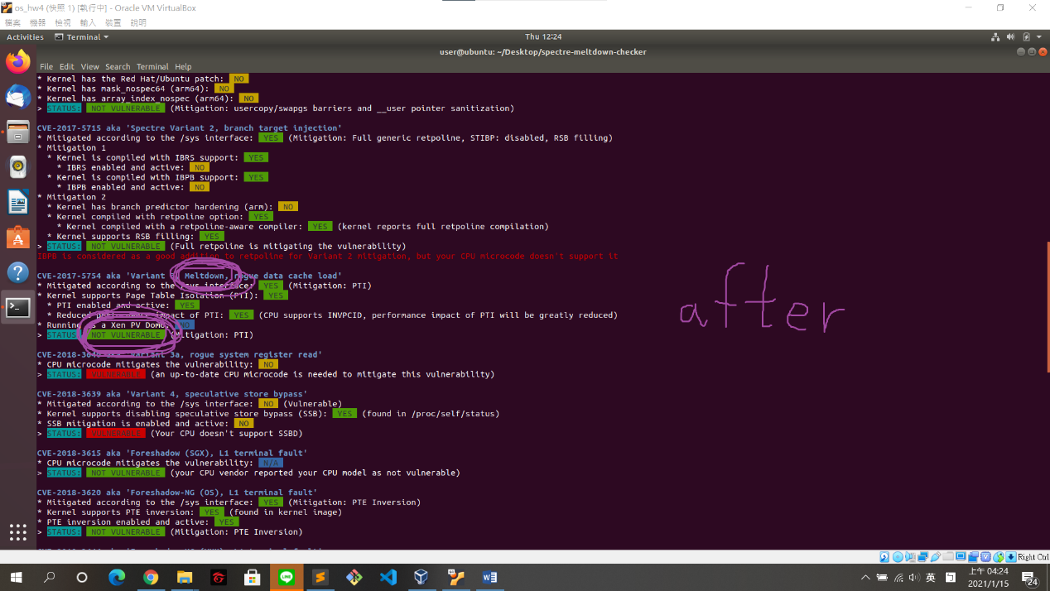

VULNERABLE 🡪 NOT VULNERABLE

$ sudo cat /proc/kallsyms | grep secret

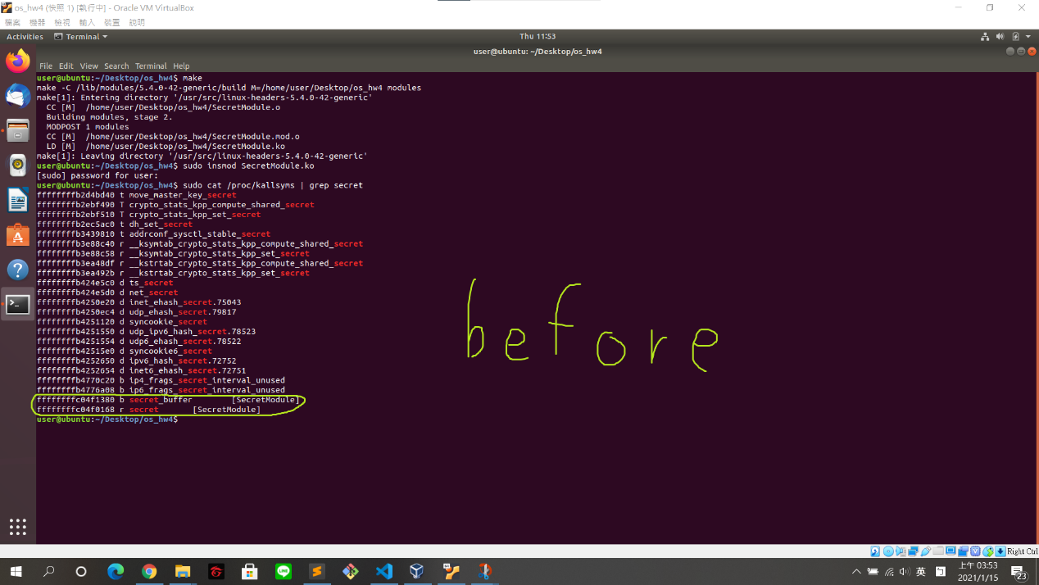

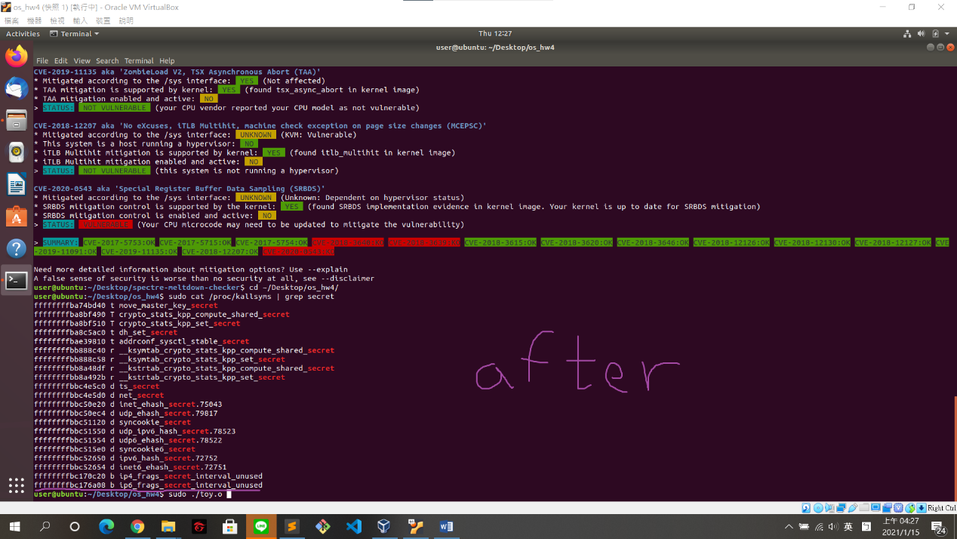

Print less (no secret module)

$ ./Meltdown_attack ffffffffc04f0168 25 137

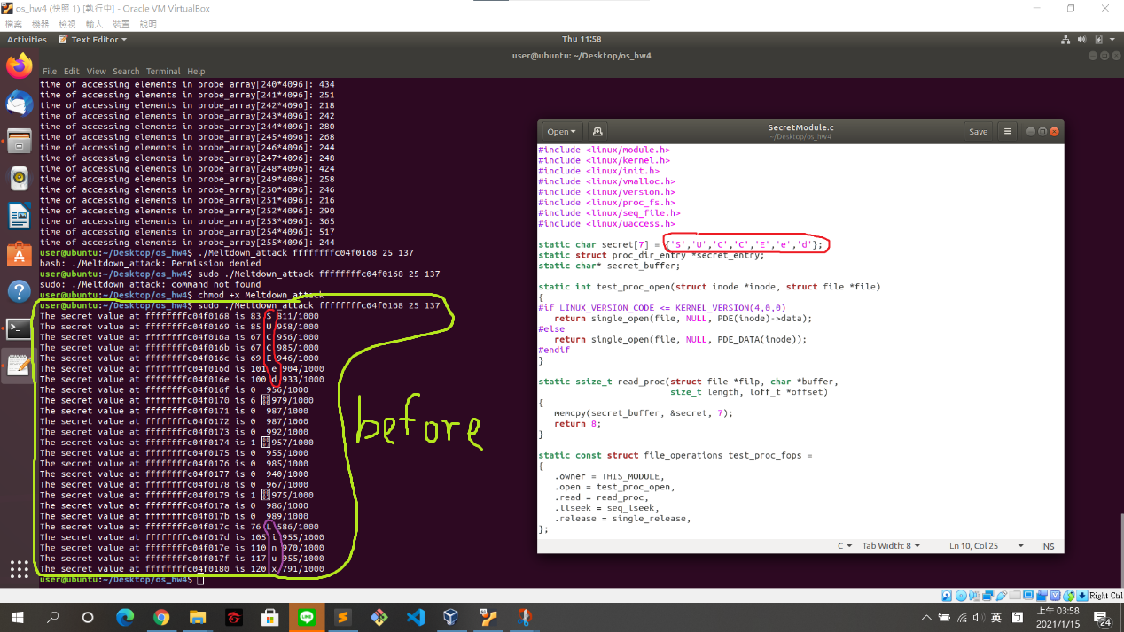

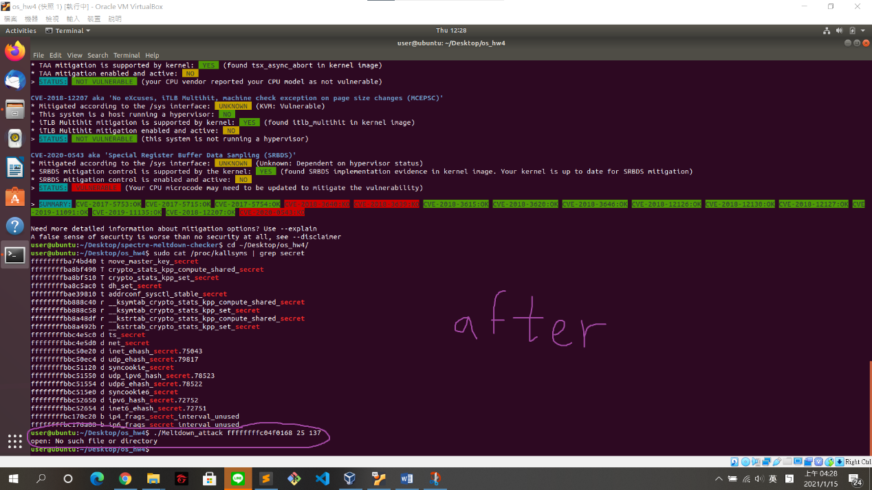

Print 🡪 no such file

CANNOT run MeltdownAttack again to see if you can still read other secret after patch .

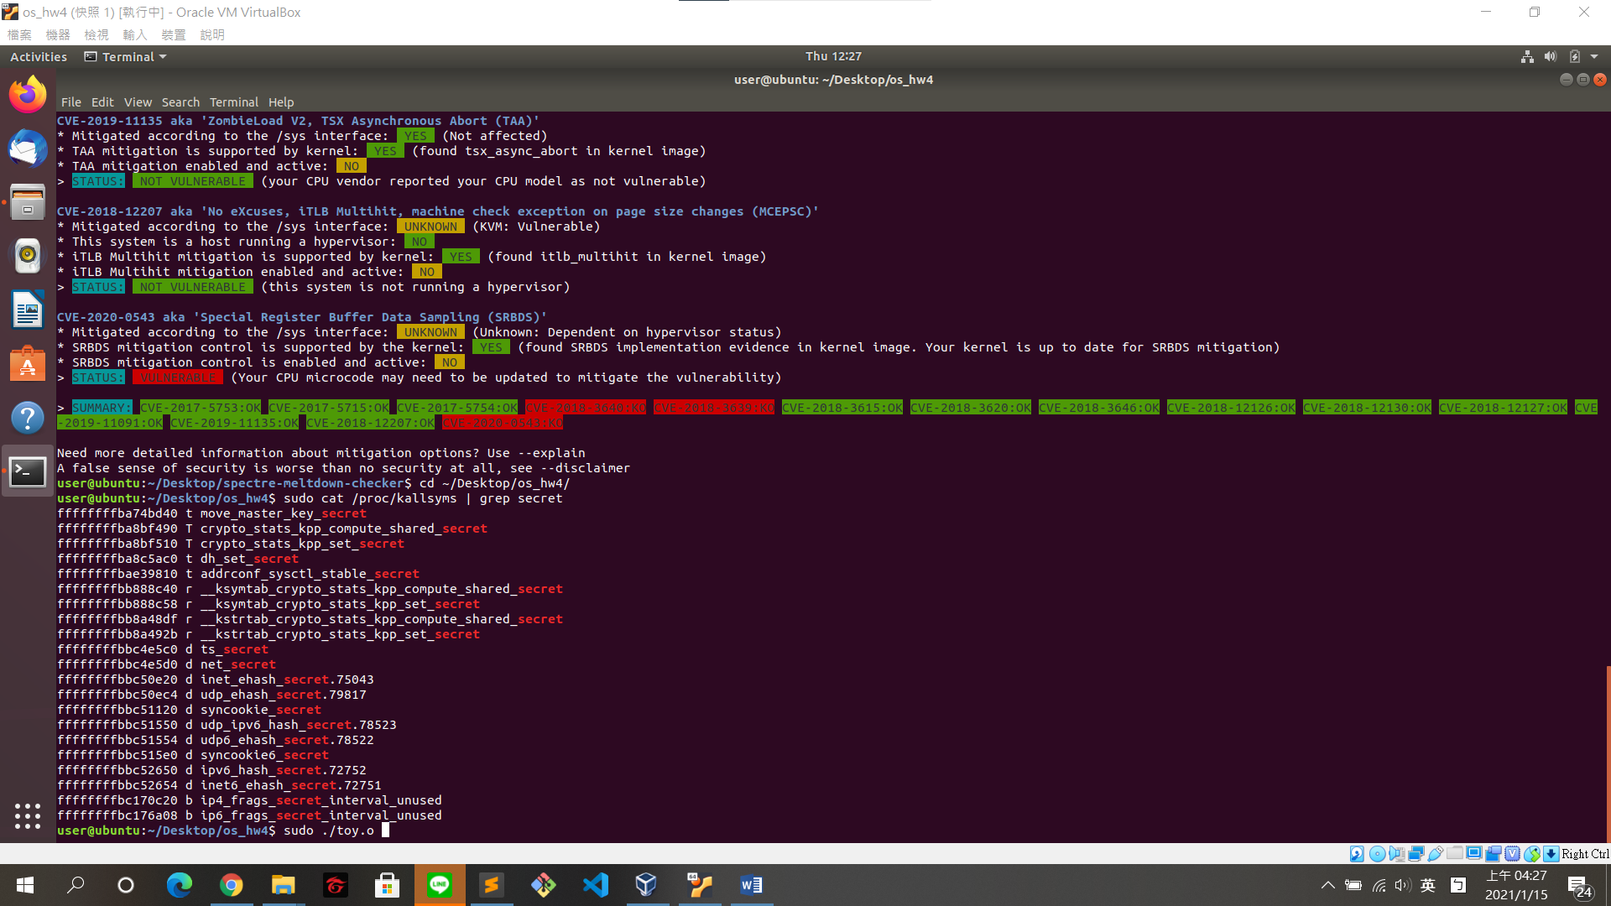

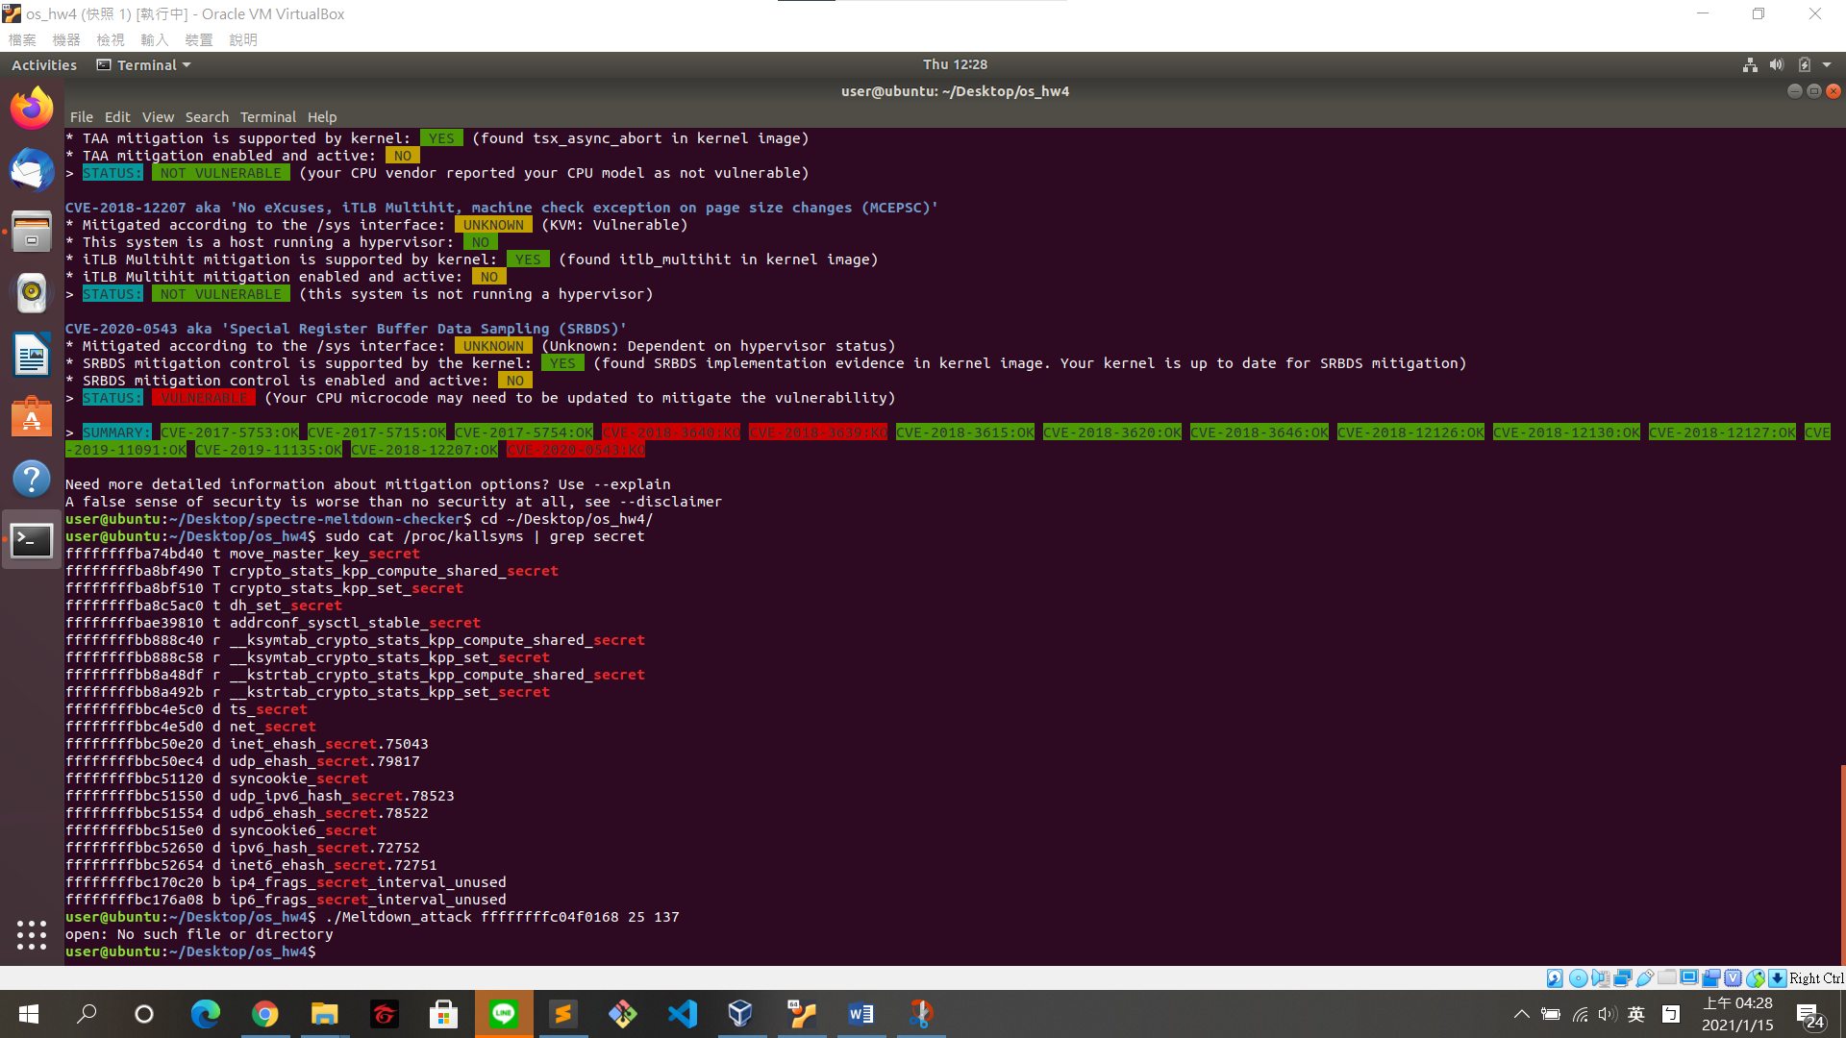

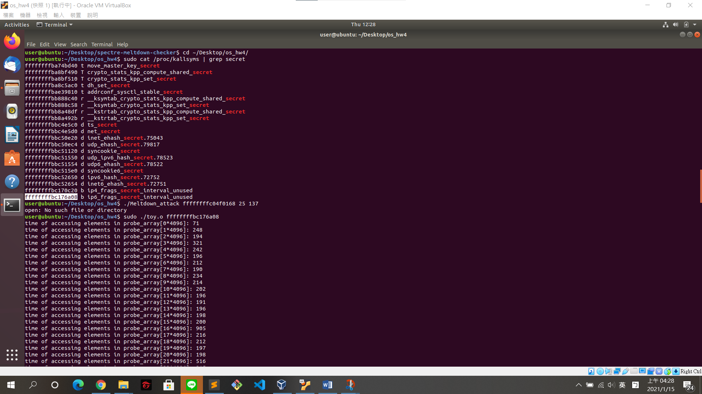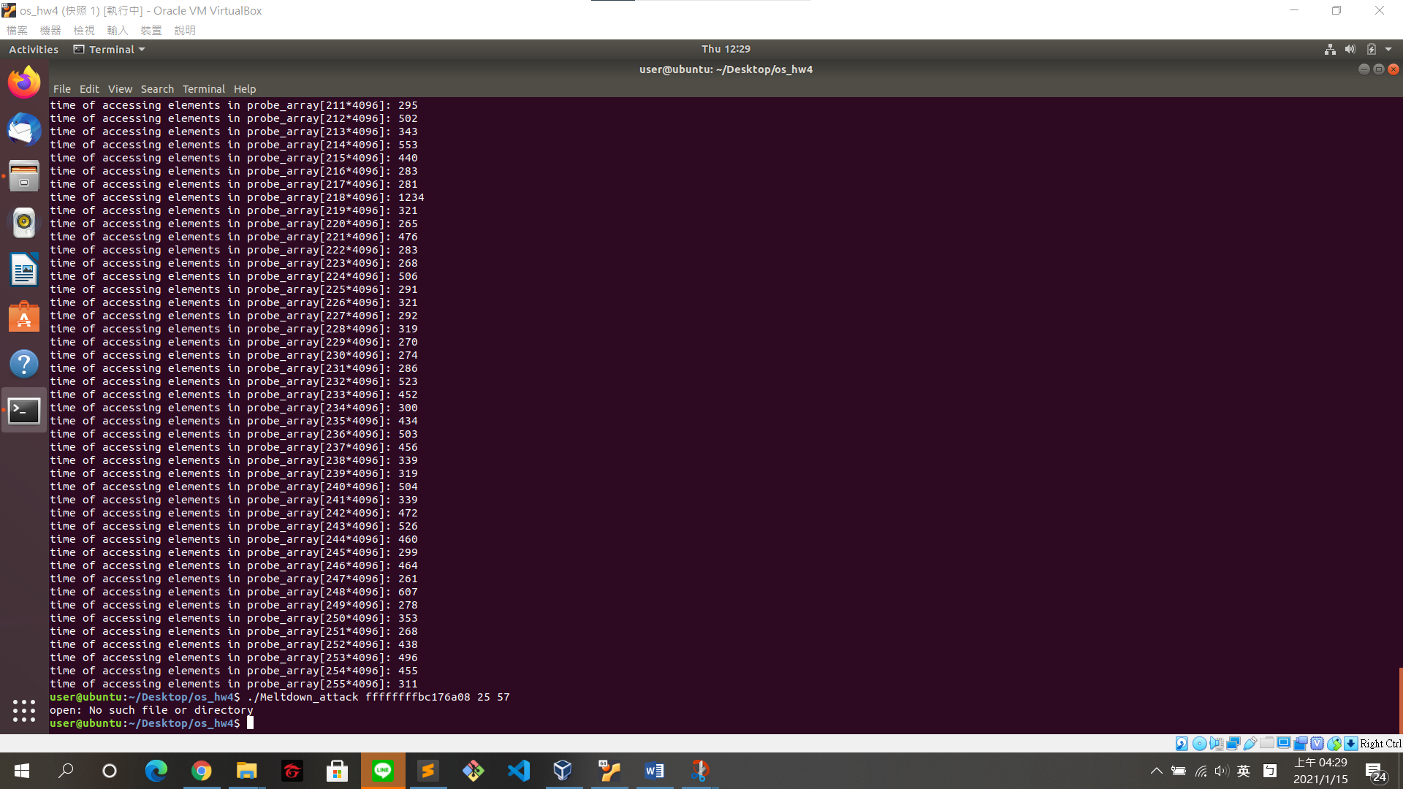

GRUB_CMDLINE_LINUX_DEFAULT

This line imports any entries to the end of the ‘linux’ line (GRUB legacy’s “kernel” line).

Original patches are available for the Spectre and Meltdown vulnerabilities

後來的patch是修復Meltdown

Conclusion

雖然錯敘是為了要最佳化，但也導致被漏洞利用而形成攻擊

可以透過補丁修復一些漏洞

Kernel不一定有做到完美的memory isolation